REV. | Description | Date
S00 | 102A-199075  增加ADP-65DW Y2G 與 ADP-65DW Y2E 做成系列 | 09/19’19
S01 | 102A-19A015  ADD ADP-65DW X2E/X2G/Z2E/Z2G MODEL NAME | 10/03‘19
S02 | 102A-206008  ITEM 7. Over Current Protection Remark部分  原始內容 : 110Vac/220Vac OCP is 4.1A~5.6A, 不計算CPK  修正為 : 110Vac/220Vac OCP SPEC is 4.1A~5.6A。  不計算CPK。 | 06/05’20
00 | 102A-208075  ADD NEW MODEL FOR ADP-65DW ZZD.  102A-208053  ADD ADP-65DW X2L /Y2L/Z2L/ X2M/Y2M/Z2M/MODEL NAME  Release mass production spec | 08/17/20
01 | 102A-215078  ADD MODEL ADP-65DW X2R/Y2R/Z2R | 05/27‘21
02 | 102A-21A225  ADD MODEL ADP-65DW EBA/ZBA/WBA/YCA | 10/28‘21
03 | 102A-21C116  ADD MODEL ADP-65DW EBAEA/EBAEB/EBAEC/ EBAED/EBAEE | 12/17‘21
04 | 102A-225021  ADD MODEL ADP-65DW EBAEF | 05/10‘22
05 | 102A-225145  ADD MODEL ADP-65DW Y2S,Y2T,X2S,X2T,Z2S,Z2T | 05/19‘22
06 | 102A-232059  ADD MODEL: ADP-65DW Y2E5, ADP-65DW X2E5, ADP-65DW X2L5, ADP-65DW Y2L5 | 02/08‘23
07 | 102A-244019  ADD MODEL ADP-65DW ZBB  102A-244020  ADD MODEL ADP-65DW ZBC | 04/08‘24

MODEL LIST
ADP-65DW Y2E | ADP-65DW Y2G | ADP-65DW X2E | ADP-65DW X2G
ADP-65DW Z2E | ADP-65DW Z2G | ADP-65DW X2L | ADP-65DW X2M
ADP-65DW Y2L | ADP-65DW Y2M | ADP-65DW Z2L | ADP-65DW Z2M
ADP-65DW ZZD | ADP-65DW X2R | ADP-65DW Y2R | ADP-65DW Z2R
ADP-65DW EBA | ADP-65DW ZBA | ADP-65DW WBA | ADP-65DW YCA
ADP-65DW EBAEA | ADP-65DW EBAEB | ADP-65DW EBAEC | ADP-65DW EBAED
ADP-65DW EBAEE | ADP-65DW EBAEF | ADP-65DW X2S | ADP-65DW X2T
ADP-65DW Y2S | ADP-65DW Y2T | ADP-65DW Z2S | ADP-65DW Z2T
ADP-65DW Y2E5 | ADP-65DW X2E5 | ADP-65DW X2L5 | ADP-65DW Y2L5
ADP-65DW ZBB | ADP-65DW ZBC
- 測試注意事項內容，未經工程師許可，不可任意變更。
Test Notice contents shall not be CHANGEd or revised without engineer permission.
- 此測試規格用於主線測試,所有項目均需被測試,因設備或線速限制無法全數測試時, 需測試worst case, QC需按抽樣標準測試所有ITEM不可只測試主線測試項目.
The production line shall perform all or worst test ITEMs/conditions, and QC shall follow the sampling plan to perform all ITEMs/conditions not just the worst condition as production did.

- 測試注意事項 :
  - 所有ATS測試時，須偵測CONNECTOR端之電壓。
  - Acoustic noise 測試須熱機 20 minute。
  - EMI 測試須熱機 20 minute。
  - 所有測試外掛1000uF系統電容, 要掛在治具上。

- 燒錄IC : N/A

- 小板(小板名稱)動態測試 : N/A
- 手調測試站：
  - VR調整測試條件如下: N/A
  - Full Load Test: 檢查滿載輸出是否符合規格
  - Min. Load Test: 檢查輕載載輸出是否符合規格
  - OTP Test : Load Condition : 3.42A
NTC31多並聯一顆10 ohm 電阻,檢查輸出電壓是否shutdown或Latch off.
  - OVP Test : Load Condition : 0A
短路R135,檢查輸出電壓是否小於27V, OVP動作模式為Latch off.
  - LED狀態: 無LED
  - AC On/Off: Power supply 連續開關機 On= 3秒, Off= 3 秒, 5 次後, 必須無損壞情形。(必加項目)

- Function test (ATS) procedure：
Input Specification Table:
INPUT VOLTAGE | MINIMUM | MAXIMUM | NOMINAL(RATED)
LOW RANGE | 90 VAC | 137 VAC | 100 VAC
HIGH RANGE | 180V AC | 264V AC | 240V AC

Output Specification Table:
OUTPUT | MINIMUM | MAXIMUM | NOMINAL(RATED)
Voltage (Vdc) | 18.5 | 20.5 | 19
Loading (Amp) | 0A | 3.42A | 3.42A

Test ITEM | Vin | Load | Spec | Remark
Inrush Current | 264V/63Hz; | 3.42A | No damage | Cold /Hot start
Turn On Time | 100V/50Hz 240V/50Hz | 3.42A | ≤ 3s | 不計算CPK
Hold up Time | 100V/50Hz | 3.42A | ≥5ms
Rise Time | 100V/50Hz 240V/50Hz | 3.42A | <40ms | From 10 to 90% voltage, monotonic
Power saving requirement | 100V/50Hz  230V/50Hz | 18W  11W  3W  1.65W  1.5W  1W  0.25W | <21W  <14W  <5W  <3W  <2.2W  <1.6W  <0.45W | Warm up 30 min
Line Regulation | 90/264V 47/63Hz | 3.42A | 18.5~20.5V | 不計算 Cpk
Line Regulation | 90/264V 47/63Hz | 0A | 18.5~20.5V | 不計算 Cpk
Ripple & Noise | 90V/47Hz 264V/63Hz | 3.42A | ≤300mVp-p | 0.1uF//10uF  20MHz bandwidth in oscilloscope. AMB:25℃
Surge Load | 100V/50Hz 240V/50Hz | Output 3.42A to 4.1A, 1s/1s | Vo >18V | AMB:25℃
Sync Dynamic | 90V/47Hz  264V/63Hz | output 0.05A to3.42A slew rate is 2.5A/us ,frequency is 100Hz and 100KHz | 18.05~20.5V
Short Circuit Protection | 90V/47Hz  264V/63Hz | Min. Load  Turn on then short | Auto-recovery
Over Current Protection | 90V/47Hz  264V/63Hz | 3.42A | OCP is 4.1-5.4A  Auto-recovery | 110Vac/220Vac OCP SPEC is 4.1A~5.6A。  不計算CPK。
Input Current | 100V /50Hz | 3.42A | Iin, max <1.5A
Full Load Efficiency | 100V/ 50Hz  240V / 50Hz | 3.42A | >83.5% | Cold
Average Efficiency | 115V/60Hz  230V/50Hz | 25%, 50%, 75% & 100% Load | >85% | Cold
Pin at No Load | 115V/60Hz  230V/50Hz | No Load | ≤0.21W | 輸出端不可接到負載
10% Load | 115V/60Hz  230V/50Hz | 0.342A | >79% | Warm up 30 min
Capacitive Load | 100V/50Hz | 3.42A
Peak load | 100V/50Hz  240V/50Hz | Output 3.42A to 6.84A 18ms/2ms | Vo>17 | 不計算CPK

Note 1: After completes required DVT test matrix, identifies and selects the worst case condition for the Production MTR. It is not required that all test conditions be tested. Example: If worst case condition for Output Ripple is minimum input voltage and maximum dc load, then that is the test condition to be used.

- Safety
  - Hi-POT test：
    - RIMARY to SECONDARY use 3000+10% Vac test , (上昇時間: DC=1Sec, AC=0.1Sec)。
Test time=1sec。Arcing current=3mA
Hi-Limit current=10mA。Lo-Limit current=0.01mA。
    - Arcing sense level=5
  - Insulation Resistance (IR) test :
The insulation resistance shall be not less than 30M ohms after application of 500Vdc/10mA for 1 minute.
  - Earth Grounding test :
N/A
  - Leakage current :
Y cap no more than 220pF.
Leakage current no more than 20uA(max) at 240Vac/50Hz.for delta product line.
  - EMI and RFI:
  - Wall mount用插座測試, DC線不可與AC線接觸,
  - 依下圖1所示使用2m長AC延長線, AC線按法規規章自然下垂於地板
  - 詳細擺設如下圖2示意， EMI 冷機 under 4dB"
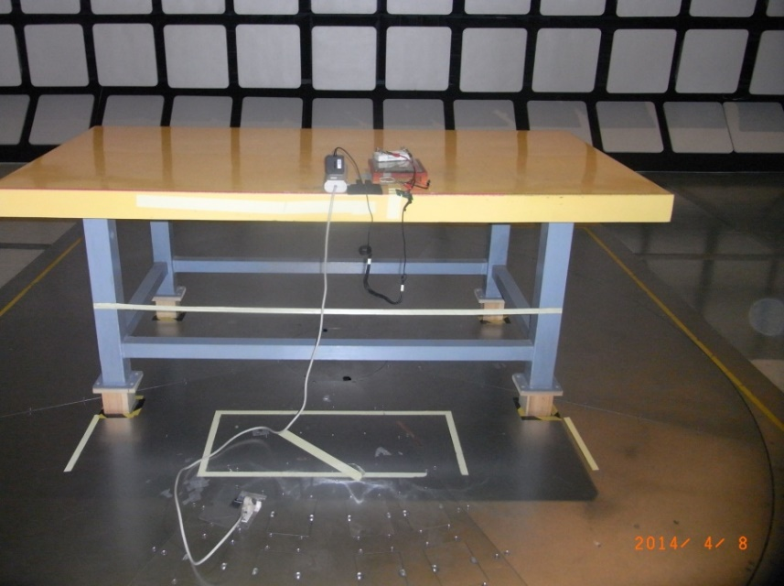
(圖一)
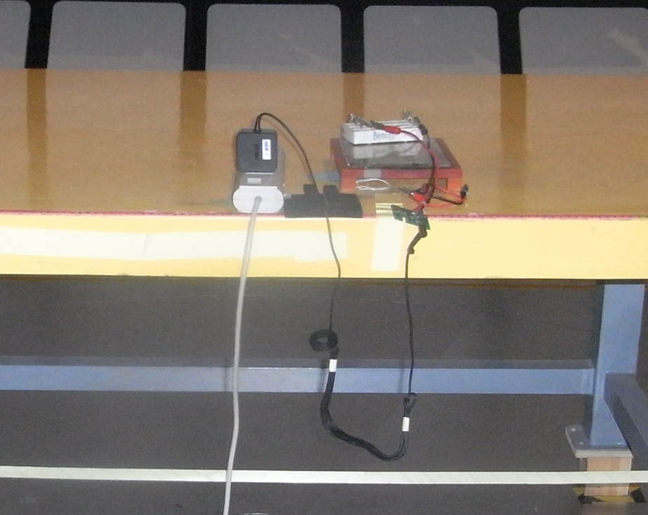
(圖二)

  - Wall mount 機種直接插 LISN 測試.測試方法如件:
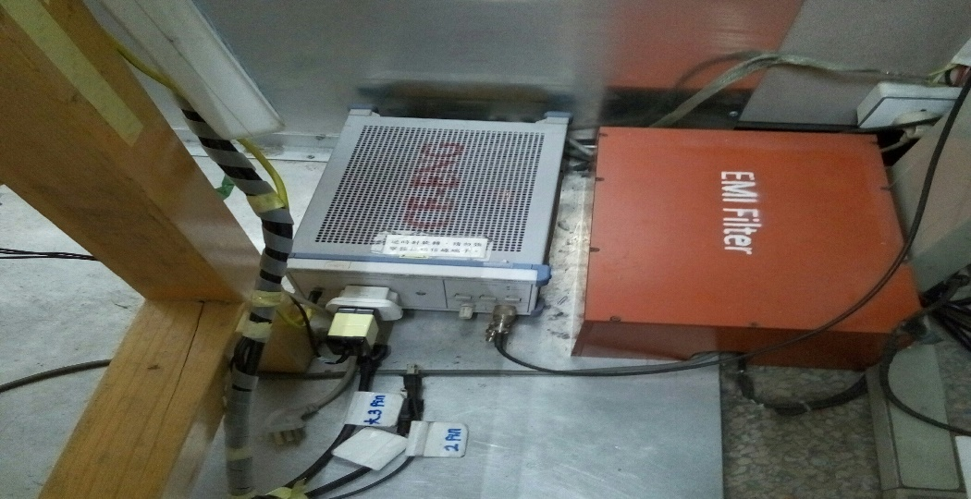

  - Thermal Test:
Follow ASUS 架設方式&製具&粗線Thermal wire,測試環境如下圖所示.
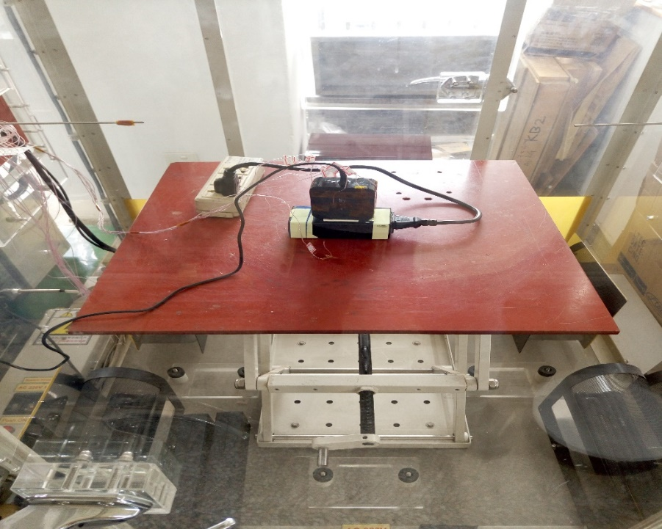
- Burn-in 測試作業規範
Follow Delta Standard burn in condition.

- I2C 測試作業規範：N/A

- FRU Data Barcode Read/Write 測試作業規範：N/A

- Loop/Gain 測試作業規範
Disturbance voltage setting 1.77V, parallel 1000uF system cap at output.

- ESD 測試作業規範
Don’t need to add 10% margin, only test as below
±15KV air discharge performance criterion B.
±12KV air discharge performance criterion A.
±8KV contact discharge performance criterion A.

- Mechanical包裝測試條件：請參照台達規範 10000-0089
(1) Drop Test
a. 條件
Carton weight
~25kg, 高度 60cm
26~50, 高度 45cm
51~75, 高度 35cm
76~100, 高度 30cm
b. 紙箱測試順序
以紙箱之1個稜角/3個稜線/6個面，每次落下試驗可取任一稜角(傾斜角不得超過10度)
c. 試驗步驟如下
Step1. 垂直落下此角 (Corner 2-3-5)
Step2. 由此角引申之最小稜線 (Edge 3-5)
Step3. 由此角引申之次長稜線 (Edge 2-5)
Step4. 由此角引申之最長稜線 (Edge 2-3)
Step5. 最小的面 (Front 5)
Step6. 相對的最小面 (Rear 6)
Step7. 次小的面 (Right 2)
Step8. 相對的次小面 (Left 4)
Step9. 最大的面 (Bottom 3)
Step10. 相對的最大面 (Top 1)
(2) Vibration Test
a. 條件
頻率 5 Hz, 振幅 20 mm, 時間 5 Min.
頻率 10 Hz, 振幅 5 mm, 時間 5 Min.
頻率 15 Hz, 振幅 2.2 mm, 時間 5 Min.
頻率 20 Hz, 振幅 1.25 mm, 時間 5 Min.

* 包裝測試後判定標準:
(1) Drop Test --- 產品 --- 外觀無損壞, 輸出正常, Hi-Pot 測試無不良.
--- 包材 --- 外箱可變形, 隔板潰縮移位不可大於同方向紙箱內尺寸之 4%,
產品自身之單體包裝 (PE Bag, 彩盒, 吸塑盒.......) 不得有變形及破損.
(2) Vibration Test --- 產品 --- 外觀無損壞, 輸出正常, Hi-Pot 測試無不良, 包裝材料無損壞.

* 如果參考機種已完成包裝測試，則不需重新測試.

